AWS Data Engineering

# Sage maker

# Used for creating Jupiter notebook in AWS

# Data Gathering

* Public Repositories
* Scrapping the webpages

# Data Cleaning - Handling missing values

* Do nothing – (ignore observations)
* Remove the entire record
* Mode – (For Categorical Data)
* Median /average value replacement – (For Numerical Data)
* Most frequent value
* Model – based imputation – (K-Nearest Neighbors (feature similarity)  
  / Regression (using correlation matrix) / Deep Learning)
* Interpolation / Extrapolation – (estimate values from other observations within the range of a discreate set of known data points)
* Forward filling / Backward filling – (filling the missing value from the preceding or succeeding values)
* Hot deck imputation – (randomly choosing the missing value from the set of related and similar variable)

# Feature Extraction

* **Dimensionality** – refers to the number of features in your dataset
* **Reducing** **dimensionality** – refers to reducing the number of features keeping only required ones
* **Feature selection**
* **Feature** **Extraction** –PCA- take features and give something less (reducing the number of features while still retaining as much information as possible
* **PCA**: **principle** **component** **analysis**: unsupervised algorithm that creates new features by linearly combining original features

# Encoding categorical data

Binarize Encoding: for features of a binary nature -- true/false, on/off, male/female etc.

Label Encoding (non binary) : may imply ordinality, can use ordinal encoder.

One – hot -encoding: change nominal categorical values into numerical values

|  |  |  |
| --- | --- | --- |
|  | Is_sunny | Is_cloudy |
| 0 | 1 | 0 |
| 1 | 0 | 1 |
| 2 | 0 | 1 |
| 3 | 1 | 0 |

Example

|  |  |
| --- | --- |
|  | Weather |
| 0 | Sunny |
| 1 | Cloudy |
| 2 | Cloudy |
| 3 | sunny |

# Numeric feature engineering

Transforming numeric values so machine learning algorithms can better analyze them.

Change numeric values so all values are on the same scale.

* **Normalization**: rescale the values into a range [0,1] .
* **Standardization**: Rescale data to have a mean of 0 & standard deviation of 1.
* **Binning**: re-organizing continuous data into bins – use qcut in python for it

# Text Feature Engineering

Text Feature Editing : transform text within data so machine learning algorithms can better analyze it.

Splitting text into smaller pieces

* Bag of words
  + tokenizes raw text and creates a statistical representation of the text.
  + Breaks up text by white spaces into single words
* N-Gram
  + Extension of bag of words which produces groups of words of size
  + Breaks up text by whitespace into groups pf words
* Orthogonal Sparse Bigram
  + Creates groups pf words of size n, returns every pair of words that includes the first word
  + Creates groups of words that always include the first word
* Term Frequency-Inverse Document Frequency (tf-idf).
  + Shows how important a word or words are o a given set of text by providing appropriate weights to terms that are common and less common.

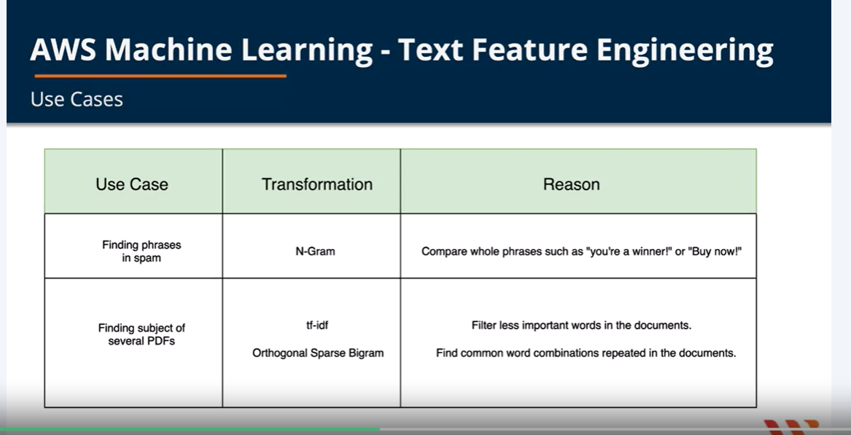

# Amazon Mechanical Turk

Amazon Mechanical Turk service

is one of the on demand and

scalable human workforce service for completing the task

where the human capabilities

are generally outperforming the computers.

# AWS Migration Services

* Migrate data from source to machine learning repository
* Several aws services to help move data
  + **Amazon data pipeline :**
    - copy data using pipeline activities
    - schedule regular data movement
  + **Aws database migration services (DMS):**
    - Move data between databases
    - MySQL to MySQL
    - Aurora to DynamoDB
  + **AWS GLUE**
    - ETL SERVICE
  + **Amazon sage maker**
    - Use jupyter notebook
  + **Amazon Athena**
    - Run sql queries on S3 data

Exploratory data analysis in AWS

# Kinesis Data streams

* Gets data from data producers such as IoT, Social media.
* Uses shards to stream data to consumers such as EC2, lambda, Kinesis Data analytics.
* Consumers then send data to a data repository such as S3, DynamoDB, Redshift, or Business Intelligence Tools.

# Building Realtime Data Streaming System-Kinesis Data Stream

**Create S3 Bucket 🡪 Create Kinesis Data Stream 🡪 Create Producer Lambda Functions**

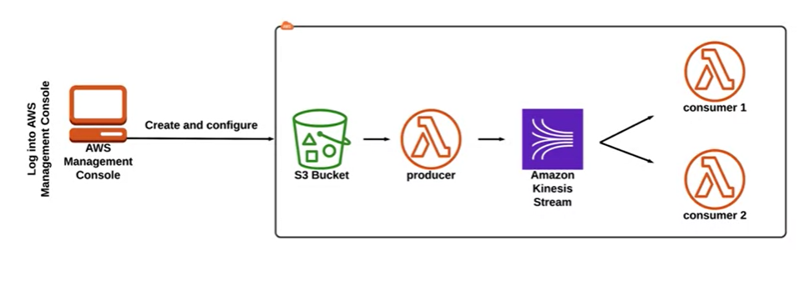

# Kinesis Data Firehose

* Receives data from producers such as IoT, social media
* Uses lambda functioning instead of shards to transmit producer data
* Lambda function puts data to data stores such as S3, Redshift, ElasticSearch, or splunk
* Can transmit directly from producers through Firehose to the data store (don’t have to use lambda intermediary)
* S3 events to store to DynamoDB

# Kinesis Data Firehose - Create S3 - VPC - VPC Flow Logs

Create S3 Bucket 🡪 Create Kinesis Firehose delivery Stream 🡪 Create Cloudwatch log group 🡪

Create VPC 🡪 Internet gateway 🡪 Subnet 🡪 EC2 Instance 🡪

🡪 Generate EC2 Logs 🡪 Create Subscription filter

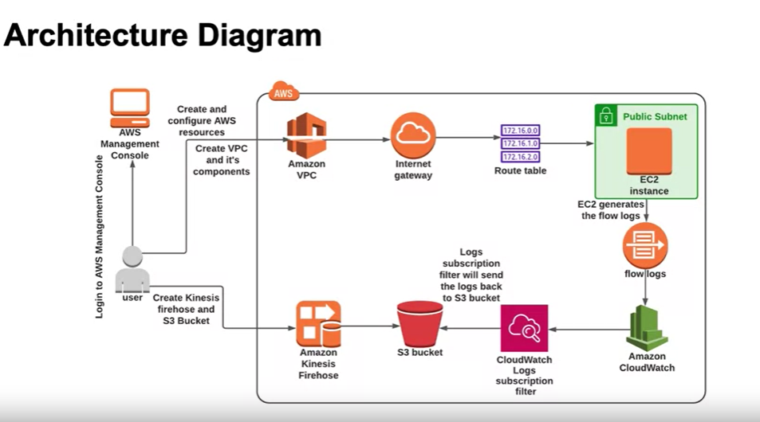

# Kinesis Video Streams

* Build video processing applications such as machine learning models
* Producers such as web cams, security cameras, audio feeds, images
* Data consumers – Kinesis video stream applications
* Stores to S3

# Kinesis Data Analytics

* Use SQL to process streaming data
* Sources: Kinesis Data Streams and Kinesis Data Firehose
* SQL queries put to S3, Redshift, or Visualization and Business Intelligence tools

# EMR – Amazon Elastic MapReduce

* Managed platform designed for cluster-centric workloads
* Amazon EMR is widely used for tasks like log analysis, data transformations, and large-scale machine learning.
* It allows the execution of prominent big data frameworks such as Apache Spark or Apache Hadoop on the AWS cloud, facilitating the processing and analysis of extensive data sets

Layers of Amazon EMR

* Storage -> (HDFS, EMRFS, Local file system)
* Cluster Resource Management -> (Responsible for Cluster Resource Management and scheduling tasks)
* Data Processing Frameworks -> (consists of Hadoop map reduce , Apache Spark)
* Applications and programs -> (helps processing and management of big data sets like HIVE, PGI, Streaming Libraries and ML Algorithms)

Create Amazon EC2 Key Pair 🡪 Create S3 Bucket 🡪 Upload application and input data to S3

🡪 launch EMR Cluster using spark 🡪 submit work to amazon EMR 🡪 validate the results

🡪 SSH to cluster

# Amazon Managed Service for Apache Flink

With amazon managed service for apache flink you can utilize java, Scala, or SQL to process and analyze streaming data

Amazon Kinesis Data Streams (Data is sent to amazon kinesis data stream)

Amazon Managed Service for Apache Flink (Reads the data from kinesis Data Stream and Processes it).

Amazon S3 Destination (Processed data is sent to a destination S3 Bucket)

# AWS Glue Concept

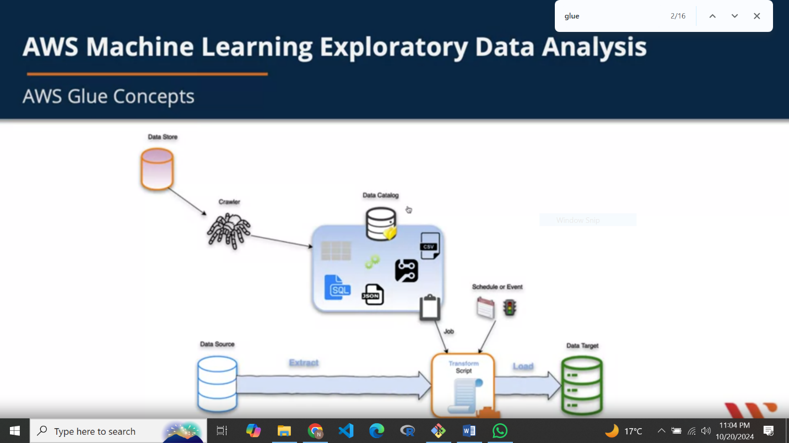

* A fully managed ETL service for categorizing, cleaning, enriching, and moving your data

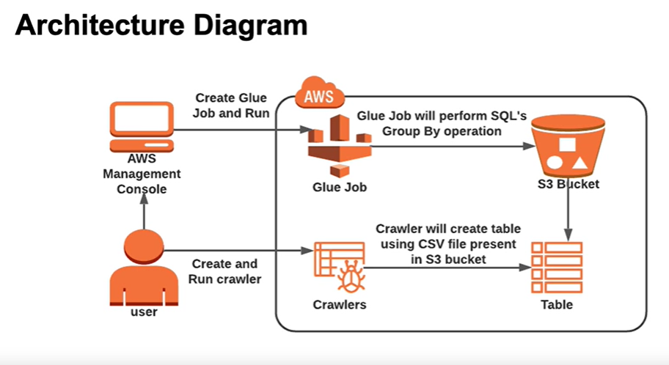

# Amazon Redshift

* A fully managed data warehouse
* Handles petabytes of data
* fully managed, cloud-based data warehouse service designed for large-scale data analytics. It allows you to run complex SQL queries on structured and semi-structured data across petabytes of data

# Amazon Data Exchange

* **AWS Data Exchange** is a service that makes it easy for users to find, subscribe to, and use third-party data in the AWS cloud.
* It provides a marketplace where data providers can publish and distribute their datasets, while consumers can access and integrate these datasets into their workflows or analytics.

# Amazon Quick sight

Data visualization tool provided by amazon

Modeling in AWS

1. Create a model in sagemaker
2. Create an endpoint configuration
3. Create HTTPS endpoint

# Machine learning models

1. **Supervised Learning 🡪 target variable to be predicted from independent variable** 
   1. Classification
   2. Regression
   3. Examples

|  |  |
| --- | --- |
| Linear Regression | Logistic Regression |
| Gradient Boosted Trees | Nearest Neighbor |
| SVM – Support Vector Machine | Neural Networks |
| Decision trees | Naïve Bayes |

1. **Unsupervised Learning 🡪 Not target or outcome to predict**
   1. Clustering
   2. Dimensionality Reduction

|  |  |
| --- | --- |
| K-means Clustering | PCA – Principle component analysis |
| t-Distributed Stochastic neighbor embedding |  |

1. **Reinforcement Machine Learning 🡪 trained to make specific decisions, trains itself continuously in an environment using trial and error**

|  |  |  |
| --- | --- | --- |
| Q Learning | Temporal difference (TD) | Monte-Carlo Tree Search |
| Asynchronous Actor-Citric Agents (A3c) |  |  |

# Hyperparameters

A hyperparameter is a parameter whose value is set before the learning process

1. **Model hyperparameter**: influence the performance of the model
2. **Algorithm hyperparameter**: affect the speed and quality of the learning process

Two approaches for choosing hyperparameters

1. **Random Search:** chooses a random combination of values for each training job
2. **Bayesian Search**: performs hyperparameter tuning as a regression problem